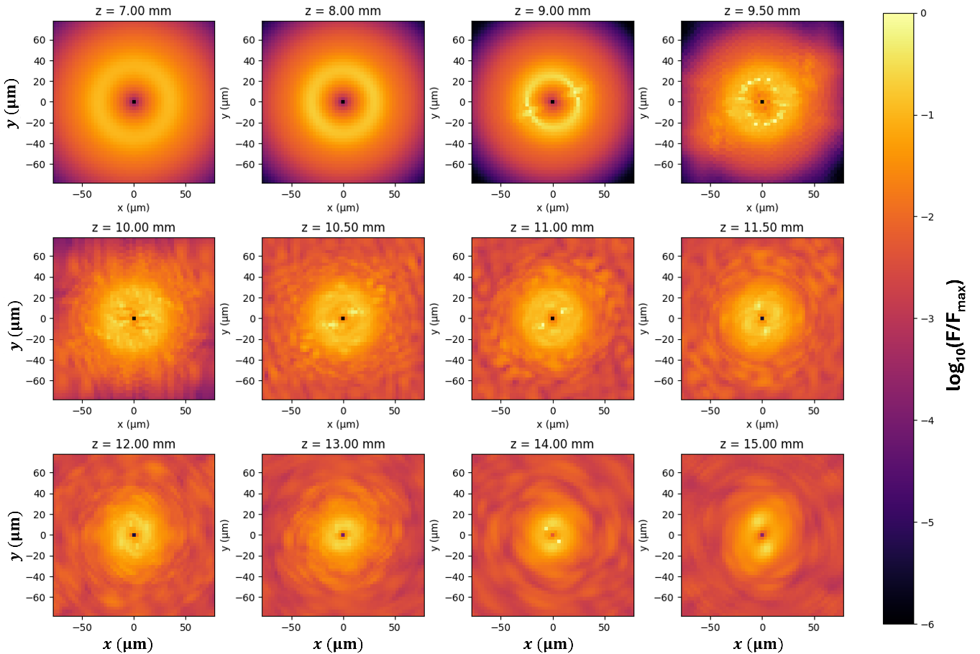
Figure 3. Representative vortex-ring breakup sequence in ordinary sapphire. Transverse fluence evolution of a focused m=1 femtosecond vortex pulse in ordinary sapphire at E=1000 nJ, corresponding to an estimated peak power of P_{est}=15.38 MW. The maps show selected propagation planes from z=7.0 mm to z=15.0 mm. The fluence is plotted on a logarithmic scale normalized to the maximum fluence in the sequence. The initially annular vortex profile develops azimuthal modulation near the nonlinear focus, followed by localized hot-spot formation and partial ring breakup. This behavior indicates the onset of filamentation-like vortex propagation in sapphire.

